**Q) List all the files beginning with the character “E” on the screen and also store them in a file called file1.**

**ls | grep -E [\bE] > file1**

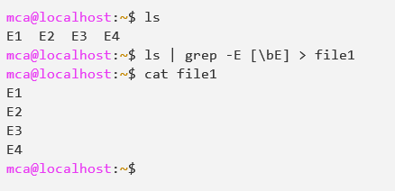

**Q) Output of ls should be displayed on the screen and from this output the line containing the word “poem” should be counted and the count should be stored in a file called file2.**

**ls | grep poem | wc -l > file2**

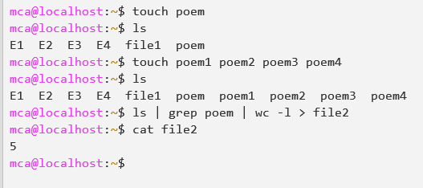

**Q) Contents of file1 and file2 should be displayed on the screen and this output should be appended to the file called file3.**

**cat file1 file2 >> file3**

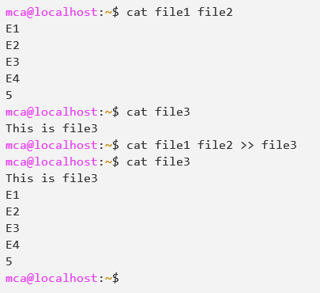

**Q) From o/p of ls the lines containing “poem” should be displayed on the screen along with the count.**

**ls | grep -o poem | cat -n**

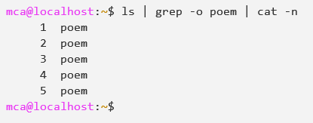

**Q) All the files present in a directory dir1 should be deleted. Any error, if it occurs while carrying out this operation should be stored in a file error log.**

**rm -i \***

